**About**

**Behind The Meme** is a [YouTube](http://knowyourmeme.com/memes/sites/youtube) webseries that explains the origins of and offers analysis on trending memes. Since its launch in August 2016, the series has grown into a popular [meme](http://knowyourmeme.com/memes/memes) explainer on the video-sharing platform, garnering over 600,000 subscribers and 50 million channel views within the first six months. Despite its active presence on YouTube, the series has been the target of derision in certain meme communities due to its tone, unoriginal content, and the perception that he kills memes after he reviews them by making them accessible to [normies](http://knowyourmeme.com/memes/normie).

**Online History**

Behind the Meme's YouTube channel launched on August 12th, 2016.[[1]](http://knowyourmeme.com/memes/people/behind-the-meme#fn1) The channel is run by Kyle Bryce. On his channel, he lists a California PO Box. His first video was uploaded on August 13th, explaining [Dicks Out For Harambe](http://knowyourmeme.com/memes/harambe-the-gorilla#dicks-out-for-harambe) (shown below).

As of March 8th, 2017, the channel has accrued over 646,000 subscribers. Some of his most popular episodes have acquired over one million views, including his videos for [Cash Me Ousside](http://knowyourmeme.com/memes/cash-me-ousside-how-bow-dah), [The Dab](http://knowyourmeme.com/memes/the-dab), [We Are Number One](http://knowyourmeme.com/memes/we-are-number-one), and [Yee](http://knowyourmeme.com/memes/yee).

**Reputation**

**Anthony Fantano Parody**

On November 12th, 2016, thatistheplan, the meme-explainer channel of [Anthony Fantano](http://knowyourmeme.com/memes/people/anthony-fantano), released a video on [Rickrolling](http://knowyourmeme.com/memes/rickroll) parodying the style of Behind The Meme. Fantano criticizes Behind the Meme's scripts by reading the entry in broken english. He also says the channel talks down to its audience like its full of 6 year olds and accuses the channel of regurgitating information on [Know Your Meme](http://knowyourmeme.com/memes/sites/knowyourmeme).

The following day, Behind The Meme responded to Fantano's video by posting a video where he addressed some of the criticisms Fantano lobbed and got his mom to [roast](http://knowyourmeme.com/memes/roasting) him by calling him a geek.

**Criticisms**

Though popular, Behind the Meme is despised in certain meme communities. Often, he is accused of being a [normie](http://knowyourmeme.com/memes/normies)and [cancer](http://knowyourmeme.com/memes/cancer) in comments on his videos (ex: shown below).[[2]](http://knowyourmeme.com/memes/people/behind-the-meme#fn2)

[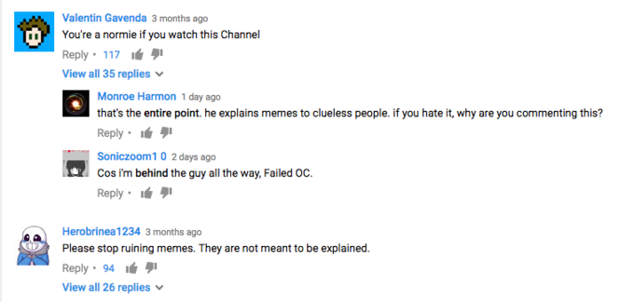](http://knowyourmeme.com/photos/1230105)

The channel is particularly loathed on meme-focused [subreddits](http://knowyourmeme.com/memes/sites/reddit) such as [/r/dankmemes](http://knowyourmeme.com/memes/dank-memes) and [/r/MemeEconomy](http://knowyourmeme.com/memes/sites/r-memeeconomy). For example, on March 8th, 2017, an image of a Behind The Meme comments section asking the channel to review [Expanding Brain](http://knowyourmeme.com/memes/expanding-brain) caused a stir in both subreddits. In /r/dankmemes, the screenshot was posted with the title, "Behind the meme, if you're out there, on Reddit, I'm begging you, don't do this to us. This meme is only a boy, it has so much to live for" (shown below).[[3]](http://knowyourmeme.com/memes/people/behind-the-meme#fn3)

[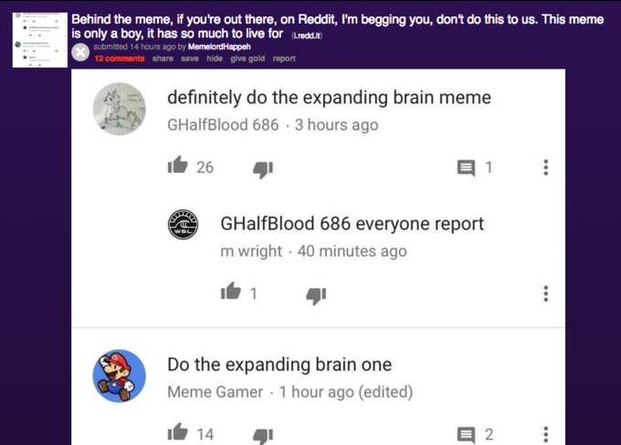](http://knowyourmeme.com/photos/1230112)

On /r/MemeEconomy, the subreddit responds to Behind the Meme actions by crying "Sell!" whenever he reviews or is encouraged to review a meme.[[4]](http://knowyourmeme.com/memes/people/behind-the-meme#fn4)

[**Zenzi**](http://knowyourmeme.com/memes/zenzi)

On February 19th, 2017, an anonymous [4chan](http://knowyourmeme.com/memes/sites/4chan) user took to /r9k/ to complain about Behind the Meme and ask how 4chan could take it down. In response, another user suggested that in every video, 4chan commenters demand he cover "Zenzi," a meme that doesn't exist, and downvote every video in which he doesn't cover Zenzi, which they thought would result in Behind The Meme getting frustrated and quitting (screenshot shown below). It appears the original thread has been deleted, though a similar thread has been archived.

[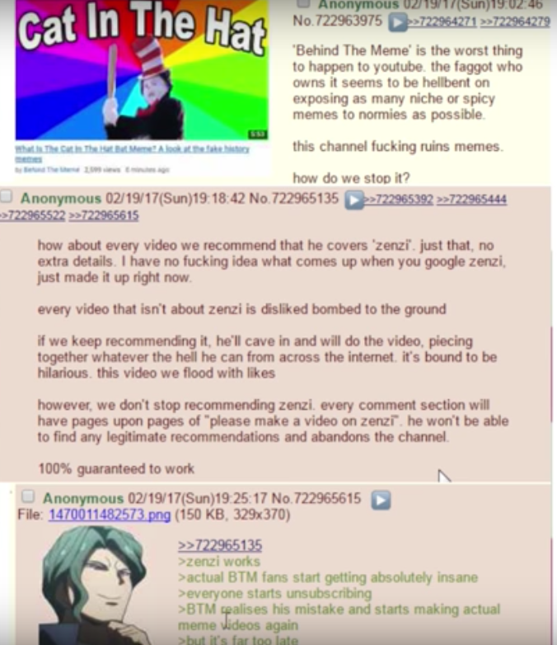](http://knowyourmeme.com/photos/1224850)

Behind The Meme quickly discovered what was going on and thwarted the attempted 4chan raid by creating an explainer video for Zenzi the same day as the raid. The video turned into less of an explainer and more of an extended riff on the [elitism of some meme communities](http://knowyourmeme.com/memes/cultures/meme-elitism). Behind The Meme's quick and accurate response to Zenzi resulted in the Zenzi raid being deemed a failure.

**Plagiarism Accusations**

Behind the Meme has been accused in the past for allegedly plagiarizing Know Your Meme. In Anthony Fantano's parody of Behind the Meme, he sarcastically says "This is the part where I regurgitate information I found on Know Your Meme, but you're so stupid, you think I researched it." The channel's tendency to steal Know Your Meme information has been a noticeable trend for its followers. For example, in his episode for [What in Tarnation](http://knowyourmeme.com/memes/what-in-tarnation), he says:[[6]](http://knowyourmeme.com/memes/people/behind-the-meme" \l "fn6)

“What in Tarnation?” is an older saying that is often associated with the Southern states of America.

The ["About" section for the Know Your Meme](http://knowyourmeme.com/about) entry for the meme reads:

“What in Tarnation?” is a rhetorical question meaning “what in damnation?”, which is often associated with Americans living in the Southern United States expressing incredulous bewilderment.

**Doxxing**

On June 3rd, 2017, Behind The Meme uploaded a "Draw My Life" episode to his channel in which he admitted his name was Kyle Bryce (shown below). On August 4th, 2017, he uploaded a since-deleted video explaining [Crash Bandicoot Woah](http://knowyourmeme.com/memes/crash-bandicoot-woah). This led to him being [doxxed](http://knowyourmeme.com/memes/doxxing).

On August 5th, 2017, Bryce was doxxed by user Jaxon Richardson of Hollaforums, who posted links to Bryce's social media profiles and his address. A thread was posted to /r/OutOftheLoop[[7]](http://knowyourmeme.com/memes/people/behind-the-meme" \l "fn7) about the doxxing the next day. This led to increased criticism of the channel and another wave of harsh criticism, particularly on /r/memeeconomy and 4chan, though it is currently unclear the extent to which the doxxing has affected Bryce's personal life.

[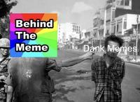](http://knowyourmeme.com/photos/1285208) [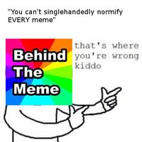](http://knowyourmeme.com/photos/1285210) [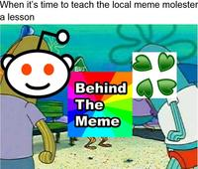](http://knowyourmeme.com/photos/1285212)

**Search Interest**

**External References**

[[1]](http://knowyourmeme.com/memes/people/behind-the-meme#fnr1) YouTube – [About Behind The Meme](https://www.youtube.com/channel/UCdsE9y553KP7Z7MDXzM1sRg/about)

[[2]](http://knowyourmeme.com/memes/people/behind-the-meme#fnr2) YouTube – [Behind the Meme Discussion](https://www.youtube.com/channel/UCdsE9y553KP7Z7MDXzM1sRg/discussion)

[[3]](http://knowyourmeme.com/memes/people/behind-the-meme#fnr3) Reddit – [/r/dankmemes post](https://www.reddit.com/r/dankmemes/comments/5y5f2n/behind_the_meme_if_youre_out_there_on_reddit_im/)

[[4]](http://knowyourmeme.com/memes/people/behind-the-meme#fnr4) Reddit – [/r/memeeconomy behind the meme search](https://www.reddit.com/r/MemeEconomy/search?q=behind+the+meme&restrict_sr=on&sort=relevance&t=all)

[[5]](http://knowyourmeme.com/memes/people/behind-the-meme#fnr5) Twitter – [@BehindTheMeme](https://twitter.com/BehindTheMeme)

[[6]](http://knowyourmeme.com/memes/people/behind-the-meme#fnr6) YouTube – [Behind the Meme](https://www.youtube.com/watch?v=x1FC0KsBiis)

[[7]](http://knowyourmeme.com/memes/people/behind-the-meme#fnr7) /r/OutOfTheLoop – "https://www.reddit.com/r/OutOfTheLoop/comments/6s0lab/did\_behind\_the\_meme\_get\_doxed/

[](http://twitter.com/knowyourmeme)

**Related Entries**13 total

|  |  |  |  |
| --- | --- | --- | --- |
| [Copypasta](http://knowyourmeme.com/memes/copypasta)  [**Copypasta**](http://knowyourmeme.com/memes/copypasta) | [Exploitables](http://knowyourmeme.com/memes/exploitables)  [**Exploitables**](http://knowyourmeme.com/memes/exploitables) | [Meme Magic](http://knowyourmeme.com/memes/meme-magic)  [**Meme Magic**](http://knowyourmeme.com/memes/meme-magic) | [Forced Meme](http://knowyourmeme.com/memes/forced-meme)  [**Forced Meme**](http://knowyourmeme.com/memes/forced-meme) |
| [Image Macros](http://knowyourmeme.com/memes/image-macros)  [**Image Macros**](http://knowyourmeme.com/memes/image-macros) | [Ironic Memes](http://knowyourmeme.com/memes/subcultures/ironic-memes)  [**Ironic Memes**](http://knowyourmeme.com/memes/subcultures/ironic-memes) | [Meme of the Month Calendars](http://knowyourmeme.com/memes/meme-of-the-month-calendars)  [**Meme of the Month Calendars**](http://knowyourmeme.com/memes/meme-of-the-month-calendars) | [KnowYourMeme](http://knowyourmeme.com/memes/sites/knowyourmeme)  [**KnowYourMeme**](http://knowyourmeme.com/memes/sites/knowyourmeme) |
| [Meme Life Cycle Charts](http://knowyourmeme.com/memes/meme-life-cycle-charts)  [**Meme Life Cycle Charts**](http://knowyourmeme.com/memes/meme-life-cycle-charts) | [Meme Elitism](http://knowyourmeme.com/memes/cultures/meme-elitism)  [**Meme Elitism**](http://knowyourmeme.com/memes/cultures/meme-elitism) | [Memes Then, Memes Now](http://knowyourmeme.com/memes/memes-then-memes-now)  [**Memes Then, Memes Now**](http://knowyourmeme.com/memes/memes-then-memes-now) | [Notice of Meme Acquisition](http://knowyourmeme.com/memes/notice-of-meme-acquisition)  [**Notice of Meme Acquisition**](http://knowyourmeme.com/memes/notice-of-meme-acquisition) |

[**View All Related Entries**](http://knowyourmeme.com/memes/memes/children)

[](http://twitter.com/knowyourmeme)

**Recent Videos**13 total

|  |  |  |  |
| --- | --- | --- | --- |
| [Spongebob Watching Behind The Meme](http://knowyourmeme.com/videos/183386-behind-the-meme) | [Long ago in a Distant Memescape...](http://knowyourmeme.com/videos/174542-behind-the-meme) | [I GOT DOXXED!!! My response to the hate and future of the channel!](http://knowyourmeme.com/videos/173803-behind-the-meme) | [Meme Police: Behind The Meme](http://knowyourmeme.com/videos/173608-behind-the-meme) |
| [Behind the meme tank engine](http://knowyourmeme.com/videos/173606-behind-the-meme) | [BEHIND THE MEME MUST BE STOPPED](http://knowyourmeme.com/videos/173457-behind-the-meme) | [Behind The Meme In A Nutshell](http://knowyourmeme.com/videos/173096-behind-the-meme) | [Behind The Meme?](http://knowyourmeme.com/videos/173076-behind-the-meme) |

[**+ Add a Video**](http://knowyourmeme.com/memes/behind-the-meme/videos/new)

[**View All Videos**](http://knowyourmeme.com/memes/people/behind-the-meme/videos)

**Recent Images**15 total

|  |  |  |  |
| --- | --- | --- | --- |
| [Mom: What the hell is in your search history Kid: Porn Mom: No, below that Kid: Behind the meme Mom: I hope its not too late to have an abortion](http://knowyourmeme.com/photos/1363020-behind-the-meme) | [AlbulushiGaming 5 days ago Just edit the Know your Meme page (Since that fucker reads off of that site) to say "Fuck you BTM Reply. 17 Hide replies Gensomura 1 day ago AlbulushiGaming how about no Reply . AlbulushiGaming 1 day ago Gensomura Screw off Normie Reply . Sheait 1 day ago (edited) normie Kek, you're still pissed about our God-Emporer winning. /Pol/ would like to have a word with you. https://www.youtube.com/watch?v=nLrwDPfizi U Reply . AlbulushiGaming 1 day ago u looked as the description, you would find that it would also be my reaction to Hillary. I also made it as a joke lol Reply . Gensomura 1 hour ago How the hell am i a normie? Reply . AlbulushiGaming 14 minutes ago Gensomura You are trying to save BTM from seeing a f*ck you message Reply . Gensomura 13 minutes ago Even Know your meme is done with the mindless hate from people like you. No, seriously, check the comments. Read more Reply . AlbulushiGaming 2 minutes ago (edited) Highlighted reply Gensomura He is sick of it because he just won't accept criticism and will probably overreact to it for that "Sweet Ad Revenue". Plus, it's hiding the real description of Proto, so BTM will get mad, not make a vid of it, so his Normie audience won't kill Proto Reply . Gensomura 1 minute ago You're effectively gatekeeping people from using a meme Reply .](http://knowyourmeme.com/photos/1292020-behind-the-meme) | [Harry Pott 1 week ago BEHIND THE MEME JUST GOT DOXXED! FUCK YES! Reply. 412 é Hide replies](http://knowyourmeme.com/photos/1287610-behind-the-meme) | [DAD! THERE IS A MONSTER UNDER MY BED! 229 Behind The Meme](http://knowyourmeme.com/photos/1286919-behind-the-meme) |
| [Know Your Meme Upgrade Behind The Meme fuck go back](http://knowyourmeme.com/photos/1286917-behind-the-meme) | [When it's time to teach the local meme molester a lesson BUS Behind The Meme](http://knowyourmeme.com/photos/1285212-behind-the-meme) | ["You can't singlehandedly normify EVERY meme" that's where you're wrong kiddo Behind The Meme](http://knowyourmeme.com/photos/1285210-behind-the-meme) | [Behind The Meme Vietnam Saigon Execution Vietnam War United States of America advertising](http://knowyourmeme.com/photos/1285208-behind-the-meme) |
| [When u have to make year-old memes so Behind The Meme can run out of new content to post](http://knowyourmeme.com/photos/1283107-behind-the-meme) | [Gumb 5:00 What is The Amazing: World Of Gumball 301K views 2 hours..](http://knowyourmeme.com/photos/1282682-behind-the-meme) | [[Hi,hi hihill Behind Know Your Meme Behind The The Meme Memne Behind The Mene imbecil! Know Your Meme Know Your Meme Behind The Meme buenos dias nowyourmem Internet Historian Subscribe 354K Behind The Behind The Meme](http://knowyourmeme.com/photos/1282545-behind-the-meme)](http://knowyourmeme.com/photos/1282545-behind-the-meme)  **[Behind The Meme](http://knowyourmeme.com/photos/1282545-behind-the-meme)** [Uploaded by consume pantaloons](http://knowyourmeme.com/photos/1282545-behind-the-meme) | [Know Your Meme Behind The Meme](http://knowyourmeme.com/photos/1231167-behind-the-meme) |

[**+ Add an Image**](http://knowyourmeme.com/memes/behind-the-meme/photos/new)

[**View All Images**](http://knowyourmeme.com/memes/people/behind-the-meme/photos)

**Facebook Comments**

[KYM Twitter](http://twitter.com/knowyourmeme)

**Top Comments**

[Donut Steel](http://knowyourmeme.com/users/donut-steel)

[**Donut Steel**](http://knowyourmeme.com/users/donut-steel)

[about a year ago](http://knowyourmeme.com/comments/3786685)

Didn't KnowYourMeme start out as a webseries explaining memes at some point as well?

+138

[**Reply**](http://knowyourmeme.com/comments/3786685#comment_3786685)

[Winday,  Lolicon Pirate](http://knowyourmeme.com/users/winday-lolicon-pirate)

[**Winday, Lolicon Pirate**](http://knowyourmeme.com/users/winday-lolicon-pirate)

[about a year ago](http://knowyourmeme.com/comments/3786986)

Great job, Behind The Meme…

http://a.kym-cdn.com/assets/blank-b3f96f160b75b1b49b426754ba188fe8.gif

+114

[**Reply**](http://knowyourmeme.com/comments/3786986#comment_3786986)

[**+ Add a Comment**](http://knowyourmeme.com/memes/people/behind-the-meme#comments_form)

**Comments**245 total

[**+ Add a Comment**](http://knowyourmeme.com/memes/people/behind-the-meme#comments_form)

**Top Entries This Month**

[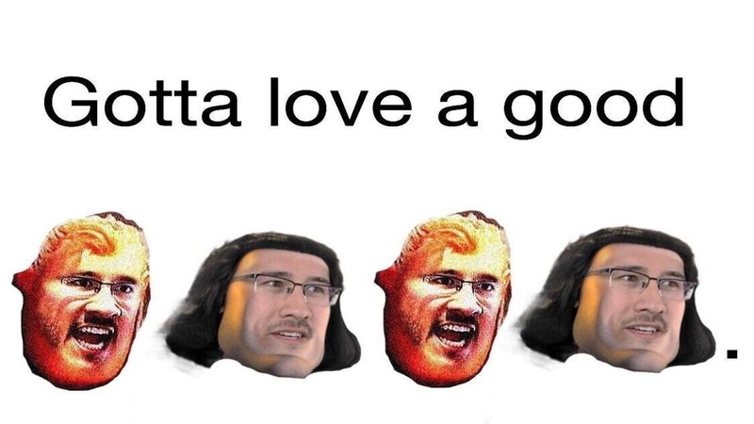](http://knowyourmeme.com/memes/lord-farquaad-markiplier-e)

[Meme](http://knowyourmeme.com/memes/lord-farquaad-markiplier-e)

[**Lord Farquaad / Markiplier E**](http://knowyourmeme.com/memes/lord-farquaad-markiplier-e)

[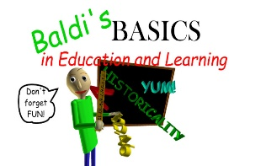](http://knowyourmeme.com/memes/subcultures/baldis-basics-in-education-and-learning)

[Subculture](http://knowyourmeme.com/memes/subcultures/baldis-basics-in-education-and-learning)

[**Baldi's Basics in Education and Learning**](http://knowyourmeme.com/memes/subcultures/baldis-basics-in-education-and-learning)

[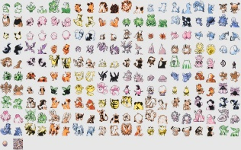](http://knowyourmeme.com/memes/events/pokemon-gold-and-silver-beta-sprites-leak)

[Event](http://knowyourmeme.com/memes/events/pokemon-gold-and-silver-beta-sprites-leak)

[**Pokémon Gold and Silver Beta Sprites Leak**](http://knowyourmeme.com/memes/events/pokemon-gold-and-silver-beta-sprites-leak)

[**View More**](javascript:;)

[**Suggest a Change**](http://knowyourmeme.com/memes/behind-the-meme/suggestions/new)   [**Edit History**](http://knowyourmeme.com/memes/behind-the-meme/edits)

**Entry Editors**[**(5)**](http://knowyourmeme.com/memes/behind-the-meme/editorships)

[Adam](http://knowyourmeme.com/users/adam--31)

[**Adam**](http://knowyourmeme.com/users/adam--31)

Know Your Meme Universal Champion

[Brad](http://knowyourmeme.com/users/brad--12)

[**Brad**](http://knowyourmeme.com/users/brad--12)

Le Editor

[Don](http://knowyourmeme.com/users/don--22)

[**Don**](http://knowyourmeme.com/users/don--22)

Administrator & Meme Daddy

[3kole5](http://knowyourmeme.com/users/3kole5)

[**3kole5**](http://knowyourmeme.com/users/3kole5)

Entry Moderator

[▼](javascript:;)[**+ Request Editorship**](http://knowyourmeme.com/memes/behind-the-meme/editorships/ask)

[**View All Editors**](http://knowyourmeme.com/memes/behind-the-meme/editorships)

**Today's Top Image Galleries**

|  |  |
| --- | --- |
| [E3-logo](http://knowyourmeme.com/memes/electronic-entertainment-expo-e3/photos/trending)  [**E3**](http://knowyourmeme.com/memes/electronic-entertainment-expo-e3/photos/trending) | [Maxresdefault](http://knowyourmeme.com/memes/cuphead/photos/trending)  [**Cuphead**](http://knowyourmeme.com/memes/cuphead/photos/trending) |
| [Wp1874080](http://knowyourmeme.com/memes/my-hero-academia/photos/trending)  [**My Hero Academia**](http://knowyourmeme.com/memes/my-hero-academia/photos/trending) | [Monster_grills](http://knowyourmeme.com/memes/monster-girls/photos/trending)  [**Monster Girls**](http://knowyourmeme.com/memes/monster-girls/photos/trending) |

[**Entry Categories**](http://knowyourmeme.com/categories)

[Events1,353](http://knowyourmeme.com/categories/event)[Memes14,130](http://knowyourmeme.com/categories/meme)[People1,288](http://knowyourmeme.com/categories/person)[Sites430](http://knowyourmeme.com/categories/site)